**RIPHAH INTERNATIONAL UNIVERSITY**



**COAL LAB**

**Practie Questions**

**NAME:** AREEBA NADEEM

**SAP ID:** 57027

**Task number 1: Subtracting two numbers**

CODE:

.model small

.stack 100h

.data

.code

main Proc

mov ah,01

int 21h

mov bx,ax

mov dl,45

mov ah,02

int 21h

mov ah,01

int 21h

mov cx,ax

mov dl,61

mov ah,02

int 21h

sub bx,cx

add bx, 30h

mov dx,bx

mov ah,02

int 21h

mov ah,4ch

int 21h

main endp

end main

**OUTPUT:**

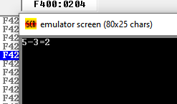

**Task number 2: Adding two numbers**

**CODE:**

.model small

.stack 100h

.data

.code

main Proc

mov ah,01

int 21h

mov b;x,ax

mov dl,43

mov ah,02

int 21h

mov ah,01

int 21h

mov cx,ax

mov dl,61

mov ah,02

int 21h

add bx,cx

sub bx,30h

mov dx,bx

mov ah,02

int 21h

mov ah,4ch

int 21h

main endp

end main

OUTPUT:

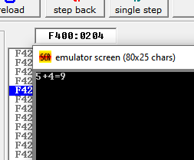

**Task number 3: Adding 3 numbers**

**CODE:**

.model small

.stack 100h

.data

.code

main Proc

mov ah,01

int 21h

mov cx,ax

mov dl, '+'

mov ah,02

int 21h

mov ah,01

int 21h

mov bx,ax

add cx,bx

sub cx, 30h

mov dx,cx

mov dl, '+'

mov ah,02

int 21h

mov ah,01

int 21h

mov bx,ax

mov dl, '='

mov ah,02

int 21h

add cx,bx

sub cx,30h

mov dx,cx

mov ah,02

int 21h

mov ah,4ch

int 21h

main endp

end main

**OUTPUT:**

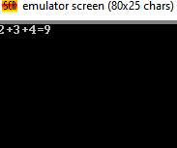

**Task number 4: x-y+z+1**

.model small

.stack 100h

.data

.code

main Proc

mov ah,01

int 21h

mov cx,ax

mov dl,45

mov ah,02

int 21h

mov ah,01

int 21h

mov bx,ax

sub cx,bx

add cx,48

mov dx,cx

mov dl,43

mov ah,02

int 21h

mov ah,01

int 21h

mov bx,ax

add bx,cx

sub bx,48

mov dx,bx

mov dl,43

mov ah,02

int 21h

mov dl,'1'

mov ah,02

int 21h

mov dl,61

mov ah,02

int 21h

add bx,1

mov dx,bx

mov ah,02

int 21h

mov ah,4ch

int 21h

main endp

end main

**OUTPUT:**

